Department of Computer Science & Engineering



LAB MANUAL
CS15-17L2 NETWORKS LABORATORY

B.Tech–VII Semester

Cochin University College of Engineering Kuttanad

INDEX

1. | Familiarizing computer network components--  a)Cables b) Connector c) Switches and Hub d) Router e) Network Cards etc.
2. | Familiarization of Structured cabling, Creating VLAN using switches and routers, Subnetting and Supernetting.
3. | Implement TCP communication in one way
4. | Implement UDP communication in one way
5. | Implement TCP communication in two way
6, | Implement UDP communication in two way
7. | Create a Single chatting program using GUI
8. | Create a Multi-Chat program using Multithreading (GUI)
9. | Program to test error detection and correction using Hamming codes
10. | Program to test RSA encryption and decryption
11. | Program to test AES encryption and decryption
12. | Simulation to test ARP and RARP
13. | Write a java program which reads data from a file and generate a message digest and prints it.
14. | Write a java program to test Huffman coding algorithm
15. | Simulate the following network topology using NS2  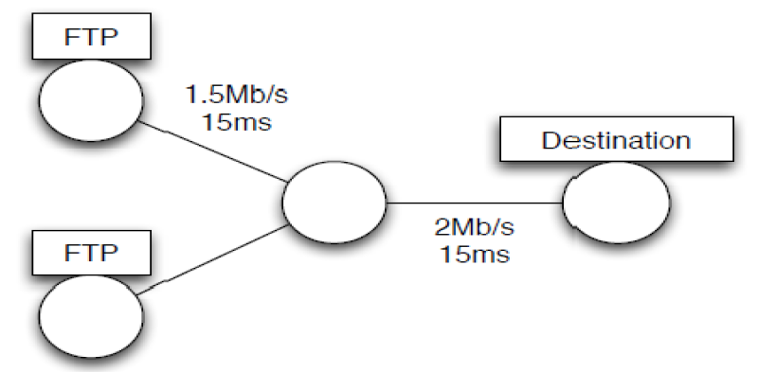
16. | Simulation to test congestion and flow control methods in TCP and UDP
17. | Simulations to test various routing protocols

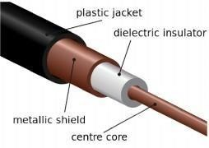
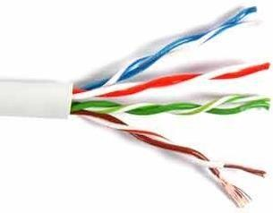

EXPERIMENT NO: 1

AIM: Familiarization with Networking components and devices(a) Cables b)Connector c)Switches and Hub d) Router e) Network Cards etc.)

Transmission media: The medium through which communication takes place b/w the PCs. At the lowest level, all computer communication involves encoding data in the form of energy and sending the energy across a transmission medium. Hardware devices attached to the computer perform encoding and decoding of data.
Coaxial Cable: The copper wiring used in now is co-axial cable (coax) the same type of wiring used for cable TV. It provides even more protection from interference than twisted pair. Instead of twisting the wires around one another to limit interference, a coaxial cable consists of a single wire surrounded by a heavier metal shield. In coaxial cable it forms a flexible cylinder around the inner wire that provides a barrier to electromagnetic radiation.

UTP CABLE: - It stands for Unshielded Twisted Pair. It consists of two insulated copper wires of thickness 1mm each. They are twisted to each other to reduce the electrical inference from the similar pair.


CRIMPING TOOL: - Crimping is joining two pieces of metal or other malleable material by deforming one or both of them to hold the other. The bend or deformity is called the crimp. Crimping is most Extensively used in metalworking. Crimping is commonly used to join bullets to their cartridge cases, for Rapid but lasting electrical connectors, securing lids on metal food cans, and myriad other applications.

CONNECTOR: - Connector may refer to a device for joining electrical circuits together. Implementation of Cables using Connectors and crimping Tools

To do these practical following steps should be done:

- Start by stripping off about 2 inches of the plastic jacket off the end of the cable. Be very careful at this point, as to not nick or cut into the wires, which are inside. Doing so could alter the characteristics of your cable, or even worse render is useless. Check the wires, one more time for nicks or cuts. If there are any, just whack the whole end off, and start over.
- Spread the wires apart, but be sure to hold onto the base of the jacket with your other hand. You do not want the wires to become untwisted down inside the jacket. Category 5 cable must only have 1/2 of an inch of 'untwisted' wire at the end; otherwise, it will be 'out of spec'.
- You have 2 end jacks, which must be installed on your cable. If you are using a pre-made cable, with one of the ends whacked off, you only have one end to install - the crossed over end. Below are two diagrams, which show how you need to arrange the cables for each type of cable end.

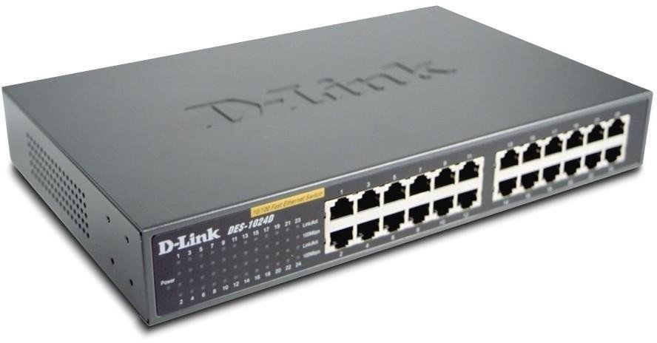

Network switch:-

A network switch (sometimes known as a switching hub) is a computer networking device that is used to connect devices together on a computer network. A switch is considered more advanced than a hub because a switch will only send a message to the device that needs or requests it, rather than broadcasting the same message out of each of its ports.[1]

A switch is a multi-port network bridge that processes and forwards data at the data link layer (layer 2) of the OSI model. Some switches have additional features, including the ability to route packets. These switches are commonly known as layer-3 or multilayer switches.

Network Hub:-

Definition: In computer networking, a hub is a small, simple, inexpensive device that joins multiple computers together. Many network hubs available today support the Ethernet standard. Other types including USB hubs also exist, but Ethernet is the type traditionally used in home networking.

Technically speaking, two different types of hubs exist:

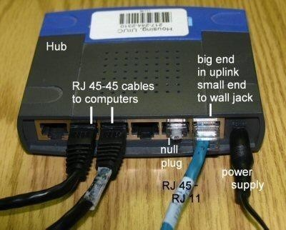
Passive hubs do not amplify the electrical signal of incoming packets before broadcasting them out to the network. Active hubs, on the other hand, do perform this amplification, as does a different type of dedicated network device called a repeater. Some people use the terms concentrator when referring to a passive hub and multiport repeater when referring to an active hub.

Router:-

Router: Routers are devices (computers) containing software that help in determining the best path out of the available paths, for a particular transmission. They consist of a combination of hardware and software. The hardware includes the physical interfaces to the various networks in the internet work. The two main pieces of software in a router are the operating system and the routing protocol.

Routers use logical and physical addressing to connect two or more logically separate networks. They accomplish this connection by organizing the large network into logical network segments or sub-networks. Each of these sub networks is given a logical address. This allows the networks to be separate but still access each other and exchange data when necessary. Data is grouped into packets, or blocks of data. Each packet, in addition to having a physical device address, has a logical network address.

Routers are frequently used to interconnect identical networks as well as to interconnect networks with different types of hardware.

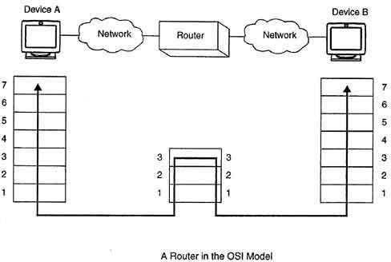

How Routers Work
Routers are interconnectivity devices that are used to transfer the datum packets along networks by visualizing the networks path. Routers visualizing the networks path to many networks such as Electronic networks, Transport networks and phonenetworks. Two ways are existing for routers operation using either control plane or forwarding plane. In control plane the router sends the precise data packets to their specific location. On the other hand in forwarding plane router does not remember the sending or receiving information about the packets.

Advantages of Routers

Routers route the data in an organized way. Routers generate a reliable connection between hosts. Routers is used for alternatively incase the main is fail to transfer data.

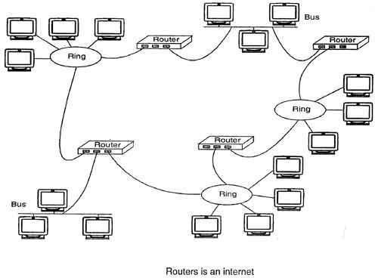
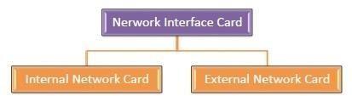

A network interface card (NIC) is a hardware component without which a computer cannot be connected over a network. It is a circuit board installed in a computer that provides a dedicated network connection to the computer. It is also called network interface controller, network adapter or LAN adapter.

Purpose
- NIC allows both wired and wireless communications.
- NIC allows communications between computers connected via local area network (LAN) as well as communications over large-scale network through Internet Protocol (IP).
- NIC is both a physical layer and a data link layer device, i.e. it provides the necessary hardware circuitry so that the physical layer processes and some data link layer processes can run on it.

Types of NIC Cards
NIC cards are of two types −

Internal Network Cards
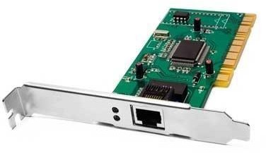
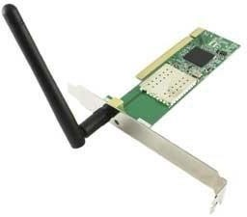
In internal networks cards, motherboard has a slot for the network card where it can be inserted. It requires network cables to provide network access. Internal network cards are of two types. The first type uses Peripheral Component Interconnect (PCI) connection, while the second type uses Industry Standard Architecture (ISA).

External Network Cards
In desktops and laptops that do not have an internal NIC, external NICs are used. External network cards are of two types: Wireless and USB based. Wireless network card needs to be inserted into the motherboard, however no network cable is required to connect to the network. They are useful while traveling or accessing a wireless signal.

EXPERIMENT NO: 2

AIM: - Familiarization of Structured cabling, Creating VLAN using switches and routers, Subnetting and Supernetting.

Structured Cabling
A structured cabling system is a complete system of cabling and associated hardware, which provides a comprehensive telecommunications infrastructure. This infrastructure serves a wide range of uses, such as to provide telephone service or transmit data through a computer network. It should not be device dependent. Structured cabling design and installation are governed by a set of standards that specify wiring data centers, offices, and apartment buildings for data or voice communications using various kinds of cable, most commonly category 5e (Cat 5e), category 6 (Cat 6), and fibre optic cabling and modular connectors.

Creating VLAN using switches and routers

When a port is enabled for bridging (default) rather than routing, all normal bridge processing is performed for an inbound packet, which is then associated with a VLAN. Its MAC Destination Address (MAC DA) and VLAN ID are used to search the MAC address table. If routing is enabled for the VLAN and the MAC DA of an inbound unicast packet is that of the internal bridge-router interface, the packet will be routed. An inbound multicast packet will be forwarded to all ports in the VLAN, plus the internal bridge-router interface if it was received on a routed VLAN.
Since a port can be configured to belong to more than one VLAN, VLAN routing might be enabled for all of the VLANs on the port, or for a subset. VLAN Routing can be used to allow more than one physical port to reside on the same subnet. It could also be used when a VLAN spans multiple physical networks, or when additional segmentation or security is required.

To create VLAN interfaces:
  - Determine the IP addresses that you want to assign to the VLAN interfaces on the switch.
For the switch to route between VLANs, the VLAN interfaces must have IP addresses. When the switch receives a packet that is destined for a VLAN or subnet, the switch forwards the packet to the destination VLAN interface based on the information in the routing table. The destination VLAN interface forwards the packet to the port to which the end device is attached.
  - Open a web browser.
  - In the browser address field, type the IP address of the smart switch.
The default IP address is 192.168.0.239 and the default subnet mask is 255.255.255.0. You are prompted to enter your password.
  - Type the password in the Password field.
The default password is password. Passwords are case-sensitive.
  - Click the Login button.
After the system authenticates you, the System Information screen displays.
  - Select Routing>IP>IP Configuration.

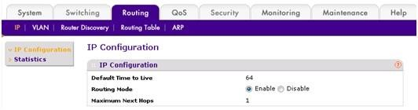

  - Next to Routing Mode, select the Enable radio button.
  - Click the Apply button. Routing is now enabled.
  - Select Switching>VLAN>Basic > VLAN Configuration.

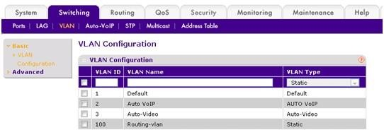
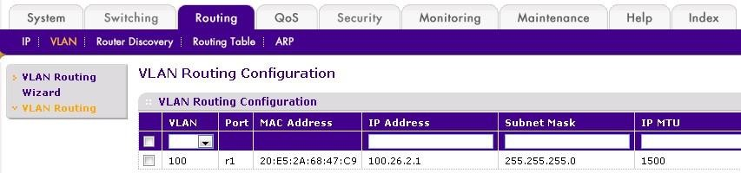

  - Create a static VLAN by specifying a VLAN ID and VLAN name, and, from the VLAN Type menu, selecting Static.
  - Click the Add button.
The new VLAN is added to the configuration.
  - Select Routing> VLAN > VLAN Routing.

  - Enable routing on the VLAN that you just created and assign an IP address and subnet mask
From the VLAN menu, select the VLAN that you just created.
In the IP address field, type the IP address that you want to assign to the VLAN routing interface.
In the Subnet Mask field, type the subnet mask that you want to assign to the VLAN routing interface.
In the IP MTU field, type 1500. 1500 is the default MTU size.
  - Click the Add button.
The VLAN routing interface is added to the configuration and becomes active.
  - Repeat steps 9—14 for all VLANs that you want to designate as VLAN routing interfaces.

Subnetting
Subnetting is the practice of dividing a network into two or smaller networks. It increases routing efficiency, which helps to enhance the security of the network and reduces the size of the broadcast domain. IP Subnetting designates high-order bits from the host as part of the network prefix. This method divides a network into smaller subnets. A subnet mask is a 32 bits address used to distinguish between a network address and a host address in IP address. A subnet mask identifies which part of an IP address is the network address and the host address.

Supernetting
In Supernetting, multiple networks are combined into a bigger network termed as a Supernetwork or Supernet. Supernetting is mainly used in Route Summarization, where routes to multiple networks with similar network prefixes are combined into a single routing entry, with the routing entry pointing to a Super network, encompassing all the networks. This in turn significantly reduces the size of routing tables and also the size of routing updates exchanged by routing protocols.

EXPERIMENT NO: 3

Aim: To write a program to implement a one way TCP communication.
Algorithm:
TCP SERVER –

- using create(), Create TCP socket.
- using bind(), Bind the socket to server address.
- using listen(), put the server socket in a passive mode, where it waits for the client to approach the server to make a connection
- using accept(), At this point, connection is established between client and server, and they are ready to transfer data.
- Go back to Step 3.
TCP Client –
- Create TCP socket.
- Connect newly created client socket to server.

Program:

Client.java

import java.net.*; import java.io.*; public class Client
{ private Socket socket = null; private DataInputStream input = null; private DataOutputStream out = null; public Client(String address, int port)
{ try {
socket = new Socket(address, port); System.out.println("Connected"); input = new
DataInputStream(System.in); out = new DataOutputStream(socket.getOutputStream()); } catch(UnknownHostException u)
{
System.out.println(u);
}
catch(IOException i)
{
System.out.println(i);
}

String line = ""; while
(!line.equals("Over"))
{ try

{

out.writeUTF(line);
}

line = input.readLine();

catch(IOException i)
{

}
try
{
System.out.println(i);
}

input.close();
out.close(); socket.close();
}
catch(IOException i)
{
System.out.println(i);
}
}

public static void main(String args[])
{
Client client = new Client("127.0.0.1", 5000);
}
}

Server.java

import java.net.*; import java.io.*; public class Server { private Socket socket = null; private ServerSocket server = null; private DataInputStream in = null; public Server(int port)
{

try

{
server = new ServerSocket(port);

System.out.println("Server started"); System.out.println("Waiting for a client ..."); socket = server.accept(); System.out.println("Client accepted");
in = new DataInputStream( new BufferedInputStream(socket.getInputStream()));

String line = ""; while (!line.equals("Over"))
{
try
{
line = in.readUTF(); System.out.println(line);

}
catch(IOException i)
{
System.out.println(i);
}
}
System.out.println("Closing connection"); socket.close(); in.close();
}
catch(IOException i)
{
System.out.println(i);
}
}

public static void main(String args[])
{
Server server = new Server(5000);
}
}

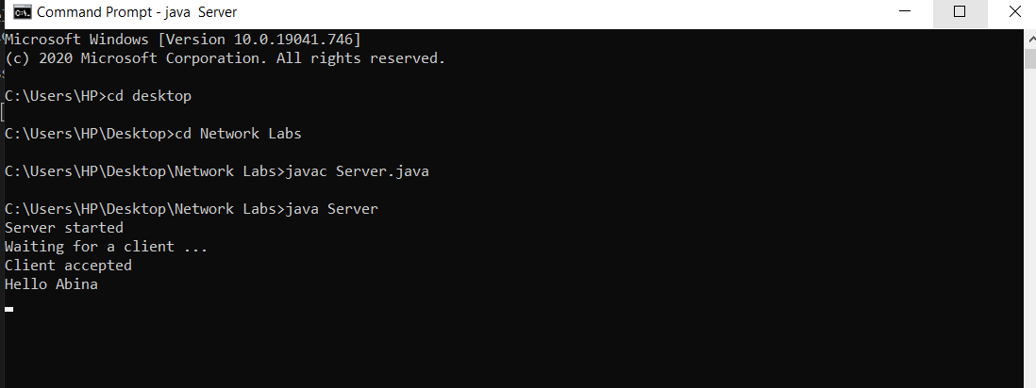
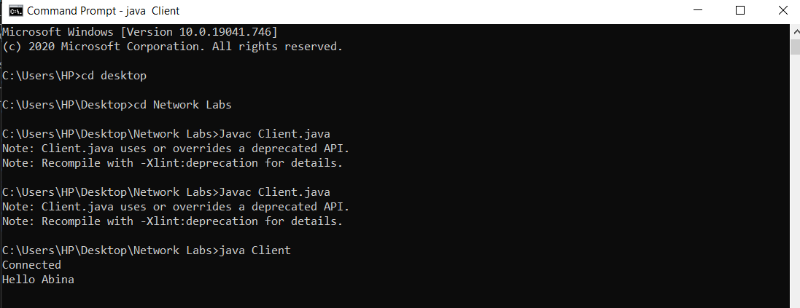

Result: The program was successfully executed.

Output:

Server:

Client:

EXPERIMENT NO: 4

Aim: To write a program to implement a one-way UDP communication.
Algorithm:

UDP Server :
- Create UDP socket.
- Bind the socket to server address.
- Wait until datagram packet arrives from client.
- Process the datagram packet and send a reply to client.
- Go back to Step 3.

UDP Client :

- Create UDP socket.
- Send message to server.
- Wait until response from server is received.
- Process reply and go back to step 2, if necessary.
- Close socket descriptor and exit.

Program:

MyServer.java

import java.net.*; import java.io.*;

class MyServer{
public static void main(String args[])throws Exception{ ServerSocket ss=new ServerSocket(3333);
Socket s=ss.accept();

DataInputStream din=new DataInputStream(s.getInputStream()); DataOutputStream dout=new DataOutputStream(s.getOutputStream());

BufferedReader br=new BufferedReader(new InputStreamReader(System.in));

String str="",str2=""; while(!str.equals("stop")){ str=din.readUTF(); System.out.println("client says: "+str); str2=br.readLine();
dout.writeUTF(str2); dout.flush();
}
din.close();
s.close(); ss.close();
}
}

MyClient.java

import java.net.*; import java.io.*; class MyClient{
public static void main(String args[])throws Exception{ Socket s=new Socket("localhost",3333);
DataInputStream din=new DataInputStream(s.getInputStream()); DataOutputStream dout=new DataOutputStream(s.getOutputStream()); BufferedReader br=new BufferedReader(new InputStreamReader(System.in)); String str="",str2=""; while(!str.equals("stop")){ str=br.readLine(); dout.writeUTF(str); dout.flush(); str2=din.readUTF(); System.out.println("Server says: "+str2);
}
dout.close(); s.close();
}
}
Result: The program was successfully executed.

Output:

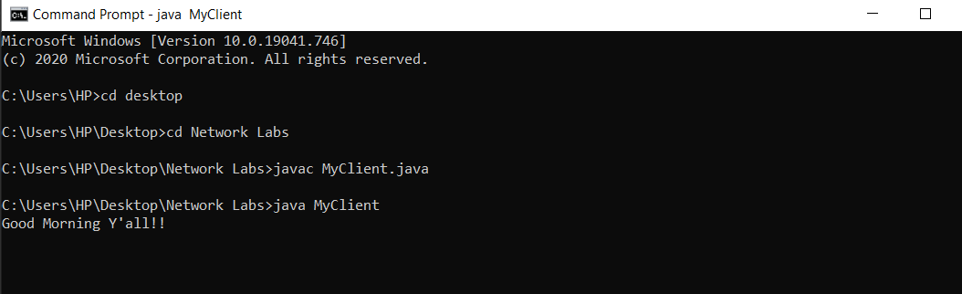
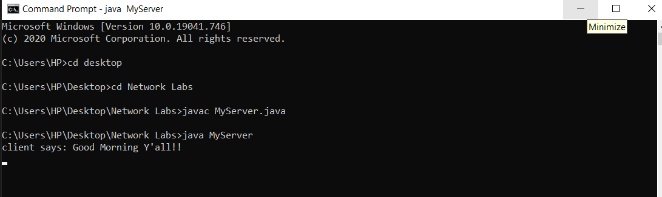

EXPERIMENT NO: 5

Aim: To write a program to implement a two way TCP communication.

Program:

TcpServer.java import java.net.*;
import java.io.*; import
java.util.*;

class TcpServer{
public static void main(String[] args) throws Exception
{
int i=0;
ServerSocket ss=new ServerSocket(5656); Socket s=ss.accept();
Scanner scan=new Scanner(System.in);
DataOutputStream dout=new DataOutputStream(s.getOutputStream()); DataInputStream dis=new DataInputStream(s.getInputStream());
while(true)
{
String str=dis.readUTF(); System.out.println("Client--->"+str);
if(str.equals("bye"))
{
System.out.println("Client Messaged BYE..Exiting");
dis.close(); s.close();
ss.close(); break;
}
System.out.println("Enter your message:"); String str1=scan.nextLine();
dout.writeUTF(str1); dout.flush();
}}}

TcpClient.java

import java.net.*;

import java.io.*; import java.util.*;

public class TcpClient{
public static void main(String[] args) throws Exception
{
Scanner scan=new Scanner(System.in); Socket s=new Socket("localhost",5656);
DataOutputStream dout=new DataOutputStream(s.getOutputStream());
DataInputStream dis=new DataInputStream(s.getInputStream()); while(true)
{
System.out.println("Write Your message"); String str=scan.nextLine();
dout.writeUTF(str); dout.flush();
if(str.equals("bye"))
{

break;

}}}
dout.close();
s.close();

}
String str1=(String)dis.readUTF(); System.out.println("Server Messaged--->"+str1);

Result: The program was executed successfully.

Output:

EXPERIMENT NO: 6

Aim: To write a program to implement UDP communication in two way.

Program:

Udpserver.java

import java.io.*;
import java.net.*;

class Udpserver
{
public static DatagramSocket serversocket; public static DatagramPacket dp;
public static BufferedReader br;
public static InetAddress ia;
public static byte buf[] = new byte[1024]; public static int cport = 2221,sport=5552;
public static void main(String[] args) throws IOException

{
serversocket = new DatagramSocket(sport); dp = new DatagramPacket(buf,buf.length); br = new BufferedReader (new InputStreamReader(System.in)); ia = InetAddress.getLocalHost();

System.out.println("Server is Running..."); while(true)
{
serversocket.receive(dp);

String str2 = new String(dp.getData(), 0, dp.getLength()); if(str2.equals("exit"))
{
System.out.println("Terminated...");

break;

}
System.out.println("Client said : " + str2);

String str3 = new String(br.readLine()); buf = str3.getBytes(); serversocket.send(new DatagramPacket(buf,str3.length(), ia, cport));
}
}
}

Udpclient.java import java.io.*; import java.net.*;

class Udpclient
{
public static DatagramSocket clientsocket; public static DatagramPacket dp;
public static BufferedReader br; public static InetAddress ia;
public static byte buf[] = new byte[1024]; public static int cport = 2221, sport = 5552;
public static void main(String[] args) throws IOException
{
clientsocket = new DatagramSocket(cport); dp = new DatagramPacket(buf, buf.length); br = new BufferedReader(new InputStreamReader(System.in)); ia
= InetAddress.getLocalHost();

System.out.println("Client is Running..."); System.out.println("Type some text if u want to Quit type 'exit'."); while(true)
{
String str1 = new String(br.readLine()); buf = str1.getBytes(); if(str1.equals("exit"))
{

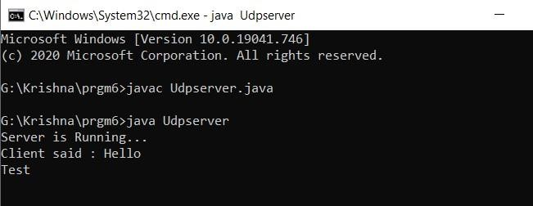
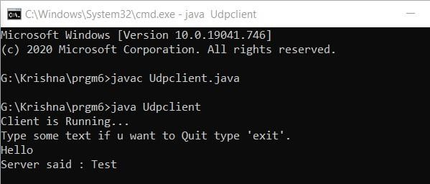
System.out.println("Terminated..");
clientsocket.send(new DatagramPacket(buf,str1.length(),ia,sport)); break;
}
clientsocket.send(new DatagramPacket(buf,str1.length(), ia, sport));

clientsocket.receive(dp);
String str4 = new String(dp.getData(), 0, dp.getLength()); System.out.println("Server said : " + str4);
}
}
}

Result: The program was successfully executed.

Output:

UdpServer:

UdpClient:

EXPERIMENT NO: 7

Aim: Write a program to implement a chatting program using GUI.

Program:

import java.awt.event.ActionEvent; import java.awt.event.ActionListener; import java.io.BufferedReader; import java.io.InputStreamReader; import java.io.PrintWriter; import java.net.InetAddress; import java.net.ServerSocket; import java.net.Socket; import javax.swing.JButton; import javax.swing.JOptionPane; import javax.swing.JTextArea; import javax.swing.JTextField; import javax.swing.WindowConstants; import javax.swing.border.EtchedBorder;
public class SingleChat extends javax.swing.JFrame { ServerSocket ss;
Socket s;
JTextField text=new JTextField();

JButton send=new JButton(); JTextArea messages=new JTextArea(); PrintWriter pout;
BufferedReader br;
ActionListener al; String ipstring; boolean ready2send=false; SingleChat pt; boolean HorC;
String cliOrServ;

public SingleChat(boolean hostOrConnect,String ip)
{

ipstring=ip; setLayout(null); setSize(500,500);
setDefaultCloseOperation(WindowConstants.EXIT_ON_CLOSE);
add(text);
text.setLocation(5,5); text.setSize(getWidth()-40-60,30); text.setEnabled(false); add(send); send.setLocation(10+text.getWidth(),text.getY()); send.setText("Send"); send.setSize(60,30); add(messages); messages.setEditable(false); messages.setBorder(new EtchedBorder()); messages.setLocation(5,text.getHeight()+text.getY()+5); messages.setSize(getWidth()-30,getHeight()-text.getY()-text.getHeight()-50);

al=new ActionListener()
{
public void actionPerformed(ActionEvent e)
{
ready2send=true;
}
};

send.addActionListener(al); pt=this;
HorC=hostOrConnect; if(HorC)
cliOrServ="\nServer: "; else cliOrServ="\nClient: ";
Messenger.start();

}

public static void main(String args[]) {

int inp=JOptionPane.showConfirmDialog(null,"Do you want to host the chat?\nYes - Act as server\nNo - Act as client","Want to host a chat?",JOptionPane.YES_NO_OPTION); if(inp==0)
{
new SingleChat(true,null).setVisible(true);
}

else

try{

{
String ipstring=JOptionPane.showInputDialog("Please enter the ip address");

InetAddress.getByName(ipstring);
new SingleChat(false,ipstring).setVisible(true);
}catch(Exception e){JOptionPane.showMessageDialog(null,"Invalid or

Unreachable IP");}
}

}

Thread Messenger=new Thread()
{
public void run()
{ try{ if(HorC)
{
messages.setText("Waiting for an incoming connection.\nEnter my ip at client side.\nMy ip: "+InetAddress.getLocalHost().getHostAddress());
ss=new ServerSocket(4444); s= ss.accept(); s.setKeepAlive(true);
}
else
{
messages.setText("Connecting to:"+ipstring+":9999");
s=new Socket(InetAddress.getByName(ipstring),4444);
}

text.setEnabled(true); pout = new PrintWriter(s.getOutputStream(),true); br=new BufferedReader(new InputStreamReader(s.getInputStream())); messages.setText(messages.getText()+"\nConnected to:"+s.getInetAddress().getHostAddress()+":"+s.getPort()); while(true)
{
if(ready2send==true)
{
pout.println(text.getText()); messages.setText(messages.getText()+"\nMe: "+text.getText()); text.setText(""); ready2send=false;
}
if(br.ready())
{
messages.setText(messages.getText()+cliOrServ+br.readLine());
}
Thread.sleep(80);
}
}catch(Exception ex)
{
JOptionPane.showMessageDialog(pt,ex.getMessage()); messages.setText("Cannot connect!");
try {
wait(3000);
} catch (InterruptedException ex1) {} System.exit(0);
}
}
};
}

Result: The program was successfully executed.

Output:

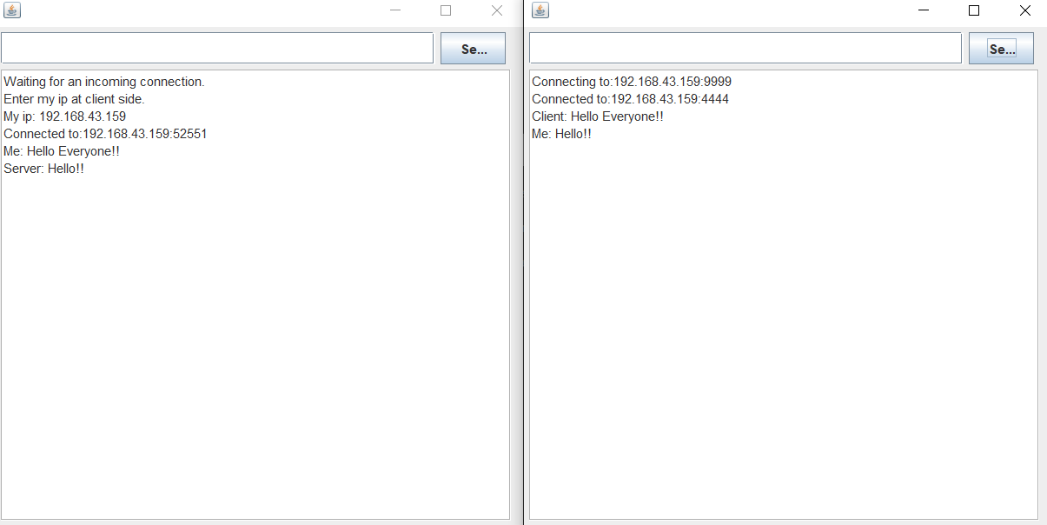
Client:

EXPERIMENT NO: 8

Aim: Write a program to implement a Multi-Chat program using Multithreading (GUI).

Program:

Server.java

import java.applet.Applet; import java.awt.*; import java.awt.event.*; import java.net.*; import java.io.*;
public class Server extends Applet implements ActionListener, Runnable Image Icon=Toolkit.getDefaultToolkit().getImage("D:/Example/emperian/jsf/ChatterA PI/src/chatterapi/hi.gif");
ServerSocket ss; Socket s;
BufferedReader br; BufferedWriter bw; TextField text;
Button sendBut, exitBut; List list;
@Override public void init(){
setForeground(Color.blue); getAppletContext().showStatus("...");

}
@Override
public void start() // class constructor
{

// super(m); setSize(300, 130); setLocation(0,0); // setIconImage(Icon);
// setResizable(false); setBackground(new Color(192, 192, 192)); this.setLayout(new
GridLayout(2, 1));

Panel panels[] = new Panel[2];
panels[0] = new Panel(); panels[1] = new Panel(); panels[0].setLayout(new BorderLayout()); panels[1].setLayout(new FlowLayout(FlowLayout.LEFT));

sendBut = new Button("Send"); exitBut = new Button("Exit");

sendBut.addActionListener(this); exitBut.addActionListener(this);
list = new List(); list.select(list.getItemCount()-1);

text = new TextField(25); panels[0].add(list);
panels[1].add(text);
panels[1].add(sendBut); panels[1].add(exitBut);

add(panels[0]);
add(panels[1]); showStatus(" ");
setVisible(true);

try
{ showStatus("connecting ...."); list.add("Send request plz
wait..."); ss = new ServerSocket(1051);//some port number, better be
above 1000 s = ss.accept();
br = new BufferedReader(new InputStreamReader(s.getInputStream())); bw = new BufferedWriter(new
OutputStreamWriter(s.getOutputStream()));
bw.write("Hi!?"); bw.newLine(); bw.flush(); Thread th;
th = new Thread(this); th.start();

}catch(Exception e){System.out.println("Error:"+e);}

}

public void run()
{
while (true)
{ try
{ showStatus("connected ");
list.add("R: "+br.readLine()); list.select(list.getItemCount()-1);

}catch (Exception e){System.out.println("Error:"+e);}
}
}

public void actionPerformed(ActionEvent ae)
{
if (ae.getSource().equals(exitBut)) System.exit(0); else { try {
bw.write(text.getText()); list.add("S: "+text.getText());
showStatus("Data sent..."); list.select(list.getItemCount()-1); bw.newLine();bw.flush();
text.setText("");
}catch(Exception x){System.out.println("Error:"+x);}
}

}

}

Client.java

import java.applet.Applet; import java.awt.*; import

java.awt.event.*; import java.net.*; import java.io.*;

public class Client extends Applet implements ActionListener, Runnable
{

Image Icon = Toolkit.getDefaultToolkit().getImage("D:/Example/emperian/jsf/ChatterAPI/src/chatterapi/ hi.gif") ;

Socket s; BufferedReader br; BufferedWriter bw; TextField text;
Button sendBut, exitBut; List list;
@Override public void init(){ setForeground(Color.blue); getAppletContext().showStatus("...");

}
@Override
public void start()
{

setSize(300, 130);
//setIconImage(Icon);
setLocation(300,0);
// setResizable(false); setBackground(new Color(192, 192, 192)); this.setLayout(new GridLayout(2, 1));

Panel panels[] = new Panel[2]; panels[0] = new Panel(); panels[1] = new Panel(); panels[0].setLayout(new BorderLayout()); panels[1].setLayout(new FlowLayout(FlowLayout.LEFT));

sendBut = new Button("Send"); exitBut = new Button("Exit");

sendBut.addActionListener(this); exitBut.addActionListener(this);
list = new

List(); TextField(25);

text = new

panels[0].add(list); panels[1].add(text); panels[1].add(sendBut);
panels[1].add(exitBut); add(panels[0]); add(panels[1]);

setVisible(true);

try
{

s = new Socket("127.0.0.1", 1051); br = new BufferedReader(new InputStreamReader(s.getInputStream())); bw = new BufferedWriter(new OutputStreamWriter(s.getOutputStream()));
Thread th;
th = new Thread(this); th.start();

}catch(Exception e){System.out.println("Error:"+e);}

}

public void run()
{
while (true)

try
{

{ list.add("R:

"+br.readLine()); list.select(list.getItemCount()-1); showStatus("connected..");
}catch (Exception h){System.out.println("Error:"+h);}
}
}

public void actionPerformed(ActionEvent ae)
{
if(ae.getSource().equals(exitBut)) System.exit(0); else
{ try {
bw.write(text.getText()); showStatus("connected.."); list.add("S: "+text.getText());
showStatus("Data sent..."); list.select(list.getItemCount()-1); bw.newLine(); bw.flush();
text.setText("");
}catch(IOException m){System.out.println("Error:"+m);}
}

}
}

EXPERIMENT NO: 9

Aim: Write a program to test error detection and correction using Hamming codes.

Program:

Hamming.java

import java.util.*;

class Hamming {
public static void main(String args[]) {
Scanner scan = new Scanner(System.in);
System.out.println("Enter the number of bits for the Hamming data:"); int n = scan.nextInt(); int a[] = new int[n];

for(int i=0 ; i < n ; i++) {
System.out.println("Enter bit no. " + (n-i) + ":"); a[n-i-1] = scan.nextInt();
}

System.out.println("You entered:"); for(int i=0 ; i < n ; i++) {
System.out.print(a[n-i-1]);
}
System.out.println();
int b[] = generateCode(a); System.out.println("Generated code is:");
for(int i=0 ; i < b.length ; i++) {
System.out.print(b[b.length-i-1]);
}

System.out.println();

System.out.println("Enter position of a bit to alter to check for error detection at the receiver end (0 for no error):"); int error = scan.nextInt();
if(error != 0) {
b[error-1] = (b[error-1]+1)%2;
}
System.out.println("Sent code is:"); for(int i=0 ; i < b.length ; i++) {
System.out.print(b[b.length-i-1]);
}
System.out.println(); receive(b, b.length - a.length);
}

static int[] generateCode(int a[]) { int b[];

int i=0, parity_count=0 ,j=0, k=0; while(i<a.length) {

if(Math.pow(2,parity_count) == i+parity_count + 1) { parity_count++;

}
else {

}
}

i++;

b = new int[a.length + parity_count];

for(i=1 ; i<=b.length ; i++) { if(Math.pow(2, j) == i) {

}
else {

}
b[i-1] = 2; j++;

b[k+j] = a[k++];

}
for(i=0 ; i<parity_count ; i++) {

b[((int) Math.pow(2, i))-1] = getParity(b, i);
}
return b;
}

static int getParity(int b[], int power) { int parity = 0;
for(int i=0 ; i < b.length ; i++) { if(b[i] != 2) {

int k = i+1;
String s = Integer.toBinaryString(k);
int x = ((Integer.parseInt(s))/((int) Math.pow(10, power)))%10; if(x == 1) {
if(b[i] == 1) {
parity = (parity+1)%2;
}
}
}
}
return parity;
}

static void receive(int a[], int parity_count) {

int power;
int parity[] = new int[parity_count]; String syndrome = new String();

for(power=0 ; power < parity_count ; power++) { for(int i=0 ; i < a.length ; i++) {
int k = i+1;
String s = Integer.toBinaryString(k); int bit = ((Integer.parseInt(s))/((int)

Math.pow(10,power)))%10;

if(bit == 1) { if(a[i] == 1) {

parity[power] = (parity[power]+1)%2;

}
}
}
syndrome = parity[power] + syndrome;
}

int error_location = Integer.parseInt(syndrome, 2); if(error_location != 0) { System.out.println("Error is at location " + error_location + ".");
a[error_location-1] = (a[error_location-1]+1)%2; System.out.println("Corrected code is:"); for(int i=0 ; i < a.length ; i++) {
System.out.print(a[a.length-i-1]);
}

}
else {

}
System.out.println();

System.out.println("There is no error in the received data.");

System.out.println("Original data sent was:"); power = parity_count-1;
for(int i=a.length ; i > 0 ; i--) { if(Math.pow(2, power) != i) {
System.out.print(a[i-1]);

power--;

}
}
else {

}

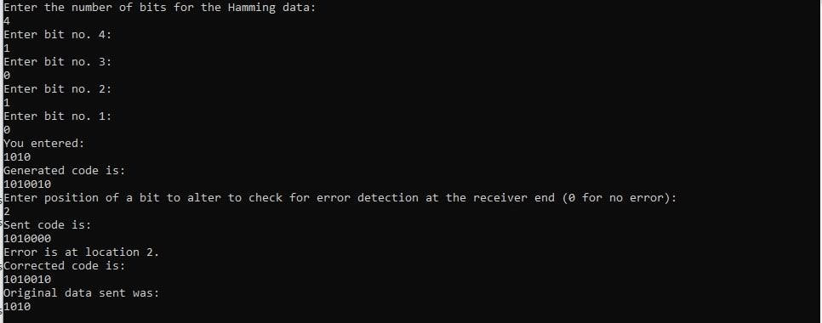
System.out.println();
}
}
Result: The program was executed successfully.

Output:

EXPERIMENT NO: - 10

Aim: Write a program to test RSA encryption and decryption.

Program:

import java.util.*; import java.math.*;

class RSA
{
public static void main(String args[])
{
Scanner sc=new Scanner(System.in); int p,q,n,z,d=0,e,i;
System.out.println("Enter the number to be encrypted and decrypted");
int msg=sc.nextInt();
double c;
BigInteger msgback;
System.out.println("Enter 1st prime number p");

p=sc.nextInt(); q=sc.nextInt();

System.out.println("Enter 2nd prime number q");

n=p*q;
z=(p-1)*(q-1);
System.out.println("the value of z = "+z);

for(e=2;e<z;e++)
{
if(gcd(e,z)==1)

{
break;
}
}
System.out.println("the value of e = "+e); for(i=0;i<=9;i++)
{

if(x%e==0)

}
int x=1+(i*z);

{
d=x/e;
break;
}

System.out.println("the value of d = "+d); c=(Math.pow(msg,e))%n;
System.out.println("Encrypted message is : -"); System.out.println(c);

BigInteger N = BigInteger.valueOf(n);
BigInteger C = BigDecimal.valueOf(c).toBigInteger(); msgback = (C.pow(d)).mod(N);
System.out.println("Decrypted message is : -"); System.out.println(msgback);

}

static int gcd(int e, int z)
{
if(e==0) return z;
else
return gcd(z%e,e);
}
}
Result: The program was executed successfully.

Output:

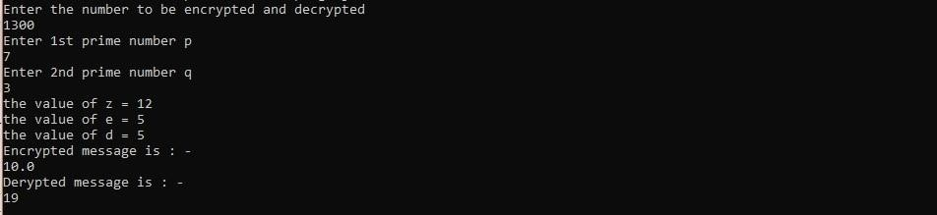

EXPERIMENT NO: - 11

Aim: Write a program to test AES encryption and decryption.

Program:

import java.io.UnsupportedEncodingException; import java.security.MessageDigest; import java.security.NoSuchAlgorithmException; import java.util.Arrays; import java.util.Base64; import javax.crypto.Cipher;
import javax.crypto.spec.SecretKeySpec; public class AES {
private static SecretKeySpec secretKey; private static byte[] key;

public static void setKey(String myKey)
{
MessageDigest sha = null; try {
key = myKey.getBytes("UTF-8"); sha
= MessageDigest.getInstance("SHA-1"); key
= sha.digest(key); key = Arrays.copyOf(key, 16);
secretKey = new SecretKeySpec(key, "AES");
}
catch (NoSuchAlgorithmException e) { e.printStackTrace();
}
catch (UnsupportedEncodingException e) { e.printStackTrace();
}
}

public static String encrypt(String strToEncrypt, String secret)
{
try
{
setKey(secret);

Cipher cipher = Cipher.getInstance("AES/ECB/PKCS5Padding"); cipher.init(Cipher.ENCRYPT_MODE, secretKey); return Base64.getEncoder().encodeToString(cipher.doFinal(strToEncrypt.getB ytes("UTF-8")));
}
catch (Exception e)
{
System.out.println("Error while encrypting: " + e.toString());
}
return null;
}

public static String decrypt(String strToDecrypt, String secret)
{
try
{
setKey(secret);
Cipher cipher = Cipher.getInstance("AES/ECB/PKCS5PADDING");
cipher.init(Cipher.DECRYPT_MODE, secretKey); return new String(cipher.doFinal(Base64.getDecoder().decode(strToDecrypt)));
}
catch (Exception e)
{
System.out.println("Error while decrypting: " + e.toString());
}
return null;
}
public static void main(String[] args)
{
final String secretKey = "wwwwww@"; String originalString = "Hello Everyone!!";
String encryptedString = AES.encrypt(originalString, secretKey) ; String decryptedString = AES.decrypt(encryptedString, secretKey) ;

System.out.println(originalString); System.out.println(encryptedString); System.out.println(decryptedString);
}}
Result: The program was executed successfully.

Output:

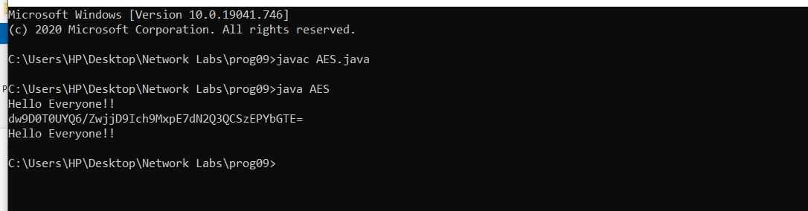

EXPERIMENT NO: - 12

Aim: Write a program to test ARP and RARP.

ARP ALGORITHMS:
Client 1. Start the program
- Using socket connection is established between client and server.
- Get the IP address to be converted into MAC address.
- Send this IP address to server.
- Server returns the MAC address to client. Server 1. Start the program
- Accept the socket which is created by the client.
- Server maintains the table in which IP and corresponding MAC addresses are stored.
- Read the IP address which is send by the client.
- Map the IP address with its MAC address and return the MAC address to client.

Program:
Serverarp.java

import java.io.*; import java.net.*; import java.util.*; class Serverarp
{
public static void main(String args[])
{ try{
ServerSocket obj=new ServerSocket(139); Socket obj1=obj.accept(); while(true)
{
DataInputStream din=new DataInputStream(obj1.getInputStream()); DataOutputStream dout=new DataOutputStream(obj1.getOutputStream()); String str=din.readLine();
String ip[]={"165.165.80.80","165.165.79.1"}; String
mac[]={"6A:08:AA:C2","8A:BC:E3:FA"}; for(int
i=0;i<ip.length;i++)
{
if(str.equals(ip[i]))
{

dout.writeBytes(mac[i]+'\n'); break;
}}
obj.close();
}}
catch(Exception e)
{
System.out.println(e);
}}}
Clientarp.java

import java.io.*; import java.net.*; import java.util.*; class Clientarp
{
public static void main(String args[])
{ try
{
BufferedReader in=new BufferedReader(new InputStreamReader(System.in)); Socket clsct=new Socket("127.0.0.1",139)
DataInputStream din=new DataInputStream(clsct.getInputStream()); DataOutputStream dout=new DataOutputStream(clsct.getOutputStream()); System.out.println("Enter the Logical address(IP):");
String str1=in.readLine(); dout.writeBytes(str1+'\n'; String str=din.readLine();
System.out.println("The Physical Address is: "+str); clsct.close();
}
catch (Exception e)
{
System.out.println(e);
}}}

Output:

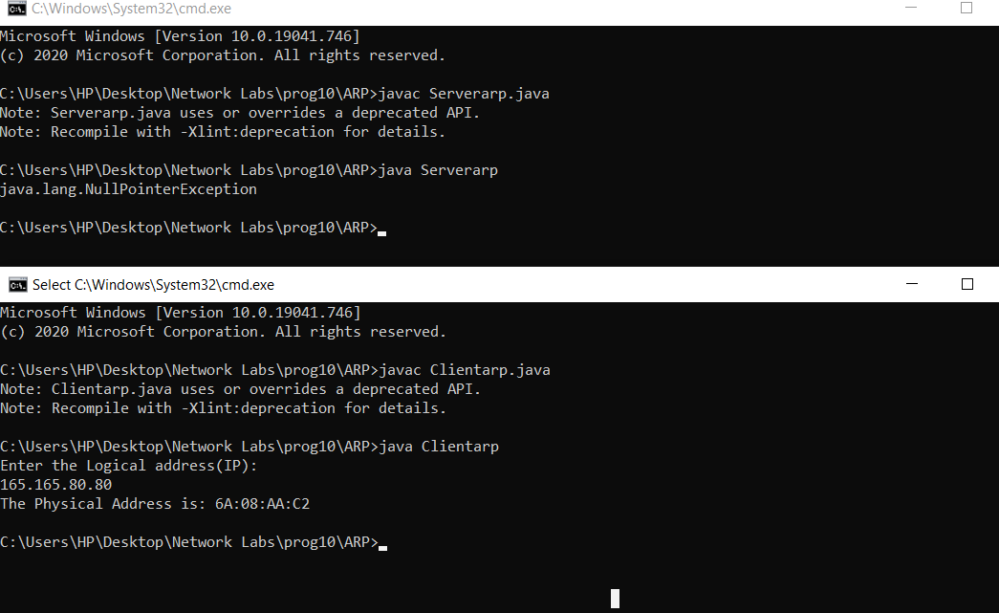

RARP

Client 1.Start the program
2. using datagram sockets UDP function is established. 3.Get the MAC address to be converted into IP address. 4.Send this MAC address to server.
45.Server returns the IP address to client.
Server 1. Start the program.
- Server maintains the table in which IP and corresponding MAC addresses are stored.
- Read the MAC address which is send by the client.
- Map the IP address with its MAC address and return the IP address to client.

Serverrarp.java

import java.io.*; import java.net.*; import java.util.*; class Serverrarp
{
public static void main(String args[])
{ try{
DatagramSocket server=new DatagramSocket(1309); while(true)
{

byte[] sendbyte=new byte[1024]; byte[] receivebyte=new byte[1024];
DatagramPacket receiver=new DatagramPacket(receivebyte,receivebyte.length); server.receive(receiver);
String str=new String(receiver.getData()); String s=str.trim();
InetAddress addr=receiver.getAddress(); int
port=receiver.getPort();
String ip[]={"165.165.80.80","165.165.79.1"}; String
mac[]={"6A:08:AA:C2","8A:BC:E3:FA"}; for(int
i=0;i<ip.length;i++)
{
if(s.equals(mac[i])){ sendbyte=ip[i].getBytes(); DatagramPacket sender = new DatagramPacket(sendbyte,sendbyte.length,addr,port); server.send(sender); break;
}}
break;
}}}catch(Exception e)
{
System.out.println(e);
}}}

Client.java

import java.io.*; import java.net.*; import java.util.*; class Clientrarp
{
public static void main(String args[])
{ try{
DatagramSocket client=new DatagramSocket(); InetAddress addr=InetAddress.getByName("127.0.0.1"); byte[] sendbyte=new byte[1024]; byte[] receivebyte=new byte[1024];
BufferedReader in=new BufferedReader(new InputStreamReader(System.in));

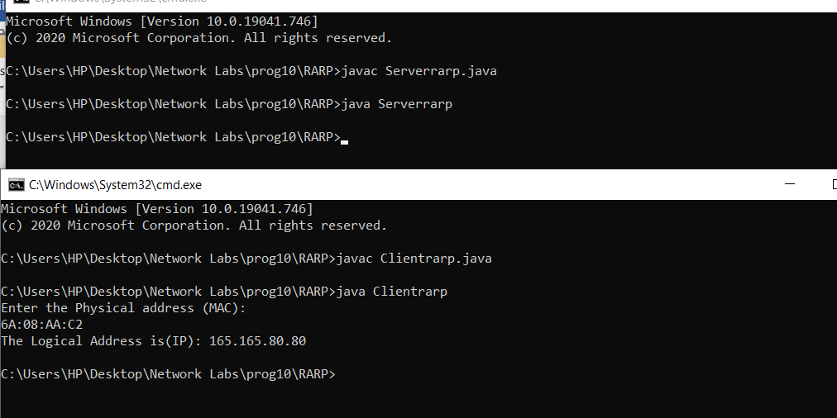
System.out.println("Enter the Physical address (MAC):") String str=in.readLine(); sendbyte=str.getBytes();
DatagramPacket sender=newDatagramPacket(sendbyte,sendbyte.length,addr,1309);
client.send(sender);
DatagramPacket receiver=new DatagramPacket(receivebyte,receivebyte.length); client.receive(receiver);
String s=new String(receiver.getData());
System.out.println("The Logical Address is(IP): "+s.trim()); client.close();
}
catch(Exception e)
{
System.out.println(e);
}}}

Output:

EXPERIMENT NO: - 13
AIM:
Write a java program which reads data from a file and generate a message digest and prints it. (To test various message digest algorithms)

PROCEDURE :
A hash function is a mathematical function that converts a numerical input value into another compressed numerical value. The input to the hash function is of arbitrary length but output is always of fixed length.
Values returned by a hash function are called message digest or simply hash values. The following picture illustrated hash function.
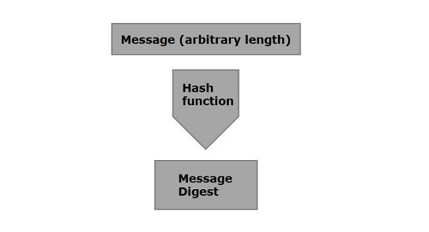
Java provides a class named MessageDigest which belongs to the package java.security. This class supports algorithms such as SHA-1, SHA 256, MD5 algorithms to convert an arbitrary length message to a message digest.
To convert a given message to a message digest, follow the steps given below:
Step 1: Create a MessageDigest object
The MessageDigest class provides a method named getInstance(). This method accepts a String variable specifying the name of the algorithm to be used and returns a MessageDigest object implementing the specified algorithm.
Create MessageDigest object using the getInstance() method as shown below.
MessageDigest md = MessageDigest.getInstance("SHA-256");

Step 2: Pass data to the created MessageDigest object
After creating the message digest object, you need to pass the message/data to it. You can do so using the update() method of the MessageDigest class, this method accepts a byte array representing the message and adds/passes it to the above created MessageDigest object.
md.update(msg.getBytes());

Step 3: Generate the message digest
You can generate the message digest using the digest() method od the MessageDigest class this method computes the hash function on the current object and returns the message digest in the form of byte array.
Generate the message digest using the digest method.
byte[] digest = md.digest();

Program:
import java.security.MessageDigest;
import java.util.Scanner;

public class MessageDigestExample {
public static void main(String args[]) throws Exception{
//Reading data from user
Scanner sc = new Scanner(System.in);
System.out.println("Enter the message");
String message = sc.nextLine();

//Creating the MessageDigest object
MessageDigest md = MessageDigest.getInstance("SHA-256");

//Passing data to the created MessageDigest Object
md.update(message.getBytes());

//Compute the message digest
byte[] digest = md.digest();
System.out.println(digest);

//Converting the byte array in to HexString format
StringBuffer hexString = new StringBuffer();

for (int i = 0;i<digest.length;i++) {
hexString.append(Integer.toHexString(0xFF & digest[i]));
}
System.out.println("Hex format : " + hexString.toString());
}
}

Output:

Enter the message
Hello how are you
[B@55f96302
Hex format: 2953d33828c395aebe8225236ba4e23fa75e6f13bd881b9056a3295cbd64d3

EXPERIENT NO: - 14
Aim:
Write Huffman coding algorithm to test compression and decompression of a text.
Procedure:
create a priority queue Q consisting of each unique character.
sort then in ascending order of their frequencies.
for all the unique characters:
create a newNode
extract minimum value from Q and assign it to leftChild of newNode
extract minimum value from Q and assign it to rightChild of newNode
calculate the sum of these two minimum values and assign it to the value of newNode
insert this newNode into the tree
return rootNode

Program:
// Huffman Coding in Java

import java.util.PriorityQueue;
import java.util.Comparator;

class HuffmanNode {
int item;
char c;
HuffmanNode left;
HuffmanNode right;
}

// For comparing the nodes
class ImplementComparator implements Comparator<HuffmanNode> {
public int compare(HuffmanNode x, HuffmanNode y) {
return x.item - y.item;
}
}

// IMplementing the huffman algorithm
public class Huffman {
public static void printCode(HuffmanNode root, String s) {
if (root.left == null && root.right == null && Character.isLetter(root.c)) {

System.out.println(root.c + " | " + s);

return;
}
printCode(root.left, s + "0");
printCode(root.right, s + "1");
}

public static void main(String[] args) {

int n = 4;
char[] charArray = { 'A', 'B', 'C', 'D' };
int[] charfreq = { 5, 1, 6, 3 };

PriorityQueue<HuffmanNode> q = new PriorityQueue<HuffmanNode>(n, new ImplementComparator());

for (int i = 0; i < n; i++) {
HuffmanNode hn = new HuffmanNode();

hn.c = charArray[i];
hn.item = charfreq[i];

hn.left = null;
hn.right = null;

q.add(hn);
}

HuffmanNode root = null;

while (q.size() > 1) {

HuffmanNode x = q.peek();
q.poll();

HuffmanNode y = q.peek();
q.poll();

HuffmanNode f = new HuffmanNode();

f.item = x.item + y.item;
f.c = '-';
f.left = x;
f.right = y;
root = f;

q.add(f);
}
System.out.println(" Char | Huffman code ");
System.out.println("--------------------");
printCode(root, "");
}
}

EXPERIMENT NO: - 15

AIM:
Simulate the network topology using NS2

PROCEDURE :
1. Creates four nodes – s1, s2, router and d.
2. Add a duplex link between s1 and router with the speed of 1.5Mb/s and 15 ms delay
3. Add a duplex link between s2 and router with the speed of 1.5Mb/s and 15 ms delay
4. Add a duplex link between s2 and router with the speed of 1.5Mb/s and 15 ms delay
5. Create a TCP connection between s1 and d and name it tcpSender1
6. Create a TCP connection between s2 and d and name it tcpSender2
7. Create a FTP application and attach it to tcpSender1
8. Create another FTP application and attach it to tcpSender2
9. Schedule the time in which the FTP agents should start
10. Schedule the time for which the simulation should run
11. Call NAM to animate this topology

PROGRAM:

set ns [new Simulator]
set nf [open trace1.tr w]
$ns trace-all $nf
set nr [open out1.nam w]
$ns namtrace-all $nr
proc finish {} {
global ns nf nr
$ns flush-trace
close $nf
close $nr
exec nam out1.nam
exit 0
}
set n0 [$ns node]
set n1 [$ns node]
set n2 [$ns node]
set n3 [$ns node]
$ns duplex-link $n0 $n2 2Mb 10ms DropTail
$ns duplex-link $n1 $n2 1Mb 10ms DropTail
$ns duplex-link $n2 $n3 3Mb 10ms DropTail
set tcp0 [new Agent/TCP]
$ns attach-agent $n0 $tcp0
set ftp0 [new Application/FTP]
$ftp0 attach-agent $tcp0
set tcp1 [new Agent/TCP]
$ns attach-agent $n1 $tcp1
set ftp1 [new Application/FTP]
$ftp1 attach-agent $tcp1
set tcpsink0 [new Agent/TCPSink]
$ns attach-agent $n3 $tcpsink0
set tcpsink1 [new Agent/TCPSink]
$ns attach-agent $n3 $tcpsink1
$ns connect $tcp0 $tcpsink0
$ns connect $tcp1 $tcpsink1
$ns at 1.0 "$ftp0 start"
$ns at 1.1 "$ftp1 start"
$ns at 10.0 "$ftp0 stop"
$ns at 10.1 "$ftp1 stop"
$ns at 10.2 "finish"
$ns run

OUTPUT:

RESULTS:
Created the given network topology and done with the network simulation.

EXPERIMENT NO: - 14

AIM:
Simulation to test congestion and flow control methods in TCP and UDP

TOPOLOGY DIAGRAM:
FEATURES OF THIS SCENARIO
Packet size = 500
FTP Start = 1.0Sec
FTP Stop = 15.0Sec
Interval =.005 Sec
CBR Start = 0.1Sec
CBR Stop = 16 Sec
Simulation End = 50Sec

PROCEDURE
1. Creates six nodes – s1, s2, routers and d1 and d2.
2. Add a duplex link between s1 and routers with the speed of 1Mb/s and 10 ms delay
3. Add a duplex link between s2 and routers with the speed of 1Mb/s and 10 ms delay
4. Create a TCP connection between s1 and d1and name it tcpSender
5. Create a UDP connection between s2 and d2 and name it udpSender
6. Create a FTP application and attach it to tcpSender
7. Create a CBR application and attach it to udpSender
8. Schedule the time in which the FTP agents should start
9. Schedule the time in which the CBR agents should start
10. Schedule the time for which the simulation should run
11. Call NAM to animate this topology

PROGRAM
set ns [new Simulator]
set nf [open "nam.out" w]
set na [open "nam.out" w]
set trace [open "t1.tr" w]
$ns namtrace-all $nf
$ns trace-all $trace
Agent/TCP set window_ 50
proc finish {} {
global ns nf na
$ns flush-trace
close $nf
close $na
exec chmod 777 t1.tr
exec awk {
{
if ( $1="r" && $4 == "5" && $5 == "tcp" ) {
data += $6
print $2,data*8/$2/1000000
}
}
} t1.tr > tcp.dat
exec awk {
{
if ( $1="r" && $4 == "4" && $5 == "cbr" ) {
data += $6
print $2,data*8/$2/1000000
}
}
} t1.tr > udp.dat
exec nam n1.nam
exec xgraph tcp.dat udp.dat
exit 0
}
set n0 [$ns node]
set n1 [$ns node]
set n2 [$ns node]
set n3 [$ns node]
set n4 [$ns node]
set n5 [$ns node]
$ns duplex-link $n0 $n2 1Mb 10ms DropTail
$ns duplex-link $n1 $n2 1Mb 10ms DropTail
$ns duplex-link $n2 $n3 3Mb 10ms DropTail
$ns duplex-link $n3 $n4 2Mb 10ms DropTail
$ns duplex-link $n3 $n5 2Mb 10ms DropTail
set tcp1 [$ns create-connection TCP/Reno $n0 TCPSink $n5 0]
set udp0 [new Agent/UDP]
$ns attach-agent $n1 $udp0
set null0 [new Agent/Null]
$ns attach-agent $n4 $null0
$ns connect $udp0 $null0
set ftp1 [new Application/FTP]
$ftp1 attach-agent $tcp1
$ftp1 set packetSize 500
$ftp1 set interval 0.005
set cbr0 [new Application/Traffic/CBR]
$cbr0 attach-agent $udp0
$cbr0 set packetSize 500
$cbr0 set interval 0.005
$ns at 1.0 "$ftp1 start"
$ns at 15 "$ftp1 stop"
$ns at 0.1 "$cbr0 start"
$ns at 16 "$cbr0 stop"
$ns at 17 "finish"
$ns run

AWK Program
#!/usr/bin/awk -f
BEGIN {
data1 = 0
data2 = 0
throughput1 = 0
throughput2 = 0
print "throughput for the network is: "
}
{
if ($1 == "r" && $4 == "5" && $5 == "tcp")
{
data1 += $6
throughput1 = data1*8/$2/1000000
}
if ($1 == "r" && $4 == "4" && $5 == "cbr")
{
data2 += $6
throughput2 = data2*8/$2/1000000
}
}
END {
print "TCP throughput is :" throughput1 "Mbps"
print "UDP throughput is : " throughput2 "Mbps"
}

OUTPUT:

RESULT:
The given network topology has been created and the calculation of throughput using Awk Script was performed with the network simulation.

EXPERIMENT NO: - 15

AIM:
Simulations to Evaluate the performance of Distance Vector (DV) and Link State (LS) routing protocols

TOPOLOGY DIAGRAM
FEATURES
Packet size = 500
Interval =.005
Traffic Start = 5Sec
Traffic End = 45Sec
Simulation End = 50Sec

LINK STATE TABLE

Link State Time
--------------------------------------------------------------
11 to 5 Dowm 10sec
11 to 5 Up 10Sec
7 to 6 Down 15Sec
7 to 6 Up 20Sec

CALCULATION

Normalized Overhead= number of routing packet/number of recived packet
Packet Delivery Ratio=number of recived packet/number of send packet

PROCEDURE
1. Creates twelve nodes – n0 to n11
2. Add a duplex links as shown in the topology diagram with the speed of 1Mb/s and 10
ms delay
3. Create a UCP connection between n0 and n5 and name it udp0
4. Create a UDP connection between n1 and n5 and name it udp1
5. Create a CBR application-cbr0 and attach it to udp0
6. Create a CBR application-cbr1 and attach it to udp1
7. Schedule the time in which the CBR agents should start
8. Schedule the time for which the simulation should run
9. Make the link n5 and n11 down at 10 seconds
10. Check the flow of packets during that time
11. Make the link n5 and n11 up at 30 seconds
12. Make the link n7 and n6 down at 15 seconds
13. Check the flow of packets during that time
14. Make the link n7 and n6 up at 20 seconds
15. Call NAM to animate this topology
16. Calculate the number of sent packets, received packets, routing packets, the packet
overhead and the packet delivery ratio by writing AWK script using the trace file.

PROGRAMS
Program For DV
set ns [new Simulator]
$ns rtproto DV
set nf [open dv1.tr w]
$ns trace-all $nf
set nr [open dv2.nam w]
$ns namtrace-all $nr
proc finish {} {
global ns nf nr
$ns flush-trace
close $nf
close $nr
exec nam dv2.nam
exit 0
}
for {set i 0} {$i<12} {incr i} {
set n$i [$ns node]
}
$ns duplex-link $n0 $n1 1Mb 10ms DropTail
$ns duplex-link $n1 $n2 1Mb 10ms DropTail
$ns duplex-link $n2 $n3 1Mb 10ms DropTail
$ns duplex-link $n3 $n4 1Mb 10ms DropTail
$ns duplex-link $n4 $n5 1Mb 10ms DropTail
$ns duplex-link $n5 $n6 1Mb 10ms DropTail
$ns duplex-link $n6 $n7 1Mb 10ms DropTail
$ns duplex-link $n7 $n8 1Mb 10ms DropTail
$ns duplex-link $n8 $n0 1Mb 10ms DropTail
$ns duplex-link $n0 $n9 1Mb 10ms DropTail
$ns duplex-link $n1 $n10 1Mb 10ms DropTail
$ns duplex-link $n9 $n11 1Mb 10ms DropTail
$ns duplex-link $n10 $n11 1Mb 10ms DropTail
$ns duplex-link $n11 $n5 1Mb 10ms DropTail
set udp0 [new Agent/UDP]
$ns attach-agent $n0 $udp0
set cbr0 [new Application/Traffic/CBR]
$cbr0 attach-agent $udp0
$cbr0 set packetSize_ 500
$cbr0 set interval_ 0.005
set null0 [new Agent/Null]
$ns attach-agent $n5 $null0
set udp1 [new Agent/UDP]
$ns attach-agent $n1 $udp1
set cbr1 [new Application/Traffic/CBR]
$cbr1 attach-agent $udp1
$cbr1 set packetSize_ 500
$cbr1 set interval_ 0.005
set null1 [new Agent/Null]
$ns attach-agent $n5 $null1
$ns connect $udp0 $null0
$ns connect $udp1 $null1
$ns rtmodel-at 10.0 down $n11 $n5
$ns rtmodel-at 30.0 up $n11 $n5
$ns rtmodel-at 15.0 down $n7 $n6
$ns rtmodel-at 20.0 up $n7 $n6
$ns at .1 "$cbr1 start"
$ns at .2 "$cbr0 start"
$ns at 45.0 "$cbr1 stop"
$ns at 45.1 "$cbr0 stop"
$ns at 50.0 "finish"
$ns run
AWK Program for DV
BEGIN {
print " performance evaluation"
send=0
recv=0
dropped=0
rout=0
}
{
if($1=="+" && $3=="0"||"1" && $5=="cbr")
{
send++
}
if($1=="r" && $4=="5" && $5=="cbr")
{
recv++
}
if($1=="d")
{
dropped++
}
if($1=="r" && $5=="rtProtoDV")
{
rout++
}
S
set ns [new Simulator]
$ns rtproto LS
set nf [open ls1.tr w]
$ns trace-all $nf
set nr [open ls2.nam w]
$ns namtrace-all $nr
proc finish {} {
global ns nf nr
$ns flush-trace
close $nf
close $nr
exec nam ls2.nam
exit 0
}
for {set i 0} {$i<12} {incr i} {
set n$i [$ns node]
}
$ns duplex-link $n0 $n1 1Mb 10ms DropTail
$ns duplex-link $n1 $n2 1Mb 10ms DropTail
$ns duplex-link $n2 $n3 1Mb 10ms DropTail
$ns duplex-link $n3 $n4 1Mb 10ms DropTail
$ns duplex-link $n4 $n5 1Mb 10ms DropTail
$ns duplex-link $n5 $n6 1Mb 10ms DropTail
$ns duplex-link $n6 $n7 1Mb 10ms DropTail
$ns duplex-link $n7 $n8 1Mb 10ms DropTail
$ns duplex-link $n8 $n0 1Mb 10ms DropTail
$ns duplex-link $n0 $n9 1Mb 10ms DropTail
$ns duplex-link $n1 $n10 1Mb 10ms DropTail
$ns duplex-link $n9 $n11 1Mb 10ms DropTail
$ns duplex-link $n10 $n11 1Mb 10ms DropTail
$ns duplex-link $n11 $n5 1Mb 10ms DropTail
set udp0 [new Agent/UDP]
$ns attach-agent $n0 $udp0
set cbr0 [new Application/Traffic/CBR]
$cbr0 attach-agent $udp0
$cbr0 set packetSize_ 500
$cbr0 set interval_ 0.005
set null0 [new Agent/Null]
$ns attach-agent $n5 $null0
set udp1 [new Agent/UDP]
$ns attach-agent $n1 $udp1
set cbr1 [new Application/Traffic/CBR]
$cbr1 attach-agent $udp1
$cbr1 set packetSize_ 500
$cbr1 set interval_ 0.005
set null1 [new Agent/Null]
$ns attach-agent $n5 $null1
$ns connect $udp0 $null0
$ns connect $udp1 $null1
$ns rtmodel-at 10.0 down $n11 $n5
$ns rtmodel-at 30.0 up $n11 $n5
$ns rtmodel-at 15.0 down $n7 $n6
$ns rtmodel-at 20.0 up $n7 $n6
$ns at .1 "$cbr1 start"
$ns at .2 "$cbr0 start"
$ns at 45.0 "$cbr1 stop"
$ns at 45.1 "$cbr0 stop"
$ns at 50.0 "finish"
$ns run
AWK Program for LS
BEGIN {
print " performance evaluation"
send=0
recv=0
dropped=0
rout=0
}
{
if($1=="+" && $3=="0"||"1" && $5=="cbr")
{
send++
}
if($1=="r" && $4=="5" && $5=="cbr")
{
recv++
}
if($1=="d")
{
dropped++
}
if($1=="r" && $5=="rtProtoLS")
{
rout++
}
}
END {
print "No of packets Send :" send
print "No of packets Received :" recv
print "No of packets dropped :" dropped
print "No of routing packets :" rout
NOH=rout/recv
PDR=recv/send
print "Normalised overhead :" NOH
print "Packet delivery ratio :" PDR
}
OUTPUT

Nam for DV

Nam for LS
Throughput for DV
performance evaluation
No of packets Send :275520
No of packets Received :26570
No of packets dropped :10
No of routing packets :1027
Normalised overhead :0.0386526
Packet delivery ratio :0.0964358
Throughput for LS
performance evaluation
No of packets Send :275818
No of packets Received :26539
No of packets dropped :10
No of routing packets :656
Normalised overhead :0.0247183
Packet delivery ratio :0.0962192
RESULT
Created the given network topology and the performance of Distance Vector (DV)
and Link State (LS) routing protocols are evaluated.

